IUIE Student Records
Report Objects Training Handout
Graduate School

IUPUI
Office of the Registrar
November 12, 2015

TABLE OF CONTENTS

Introduction ………………………………………….…..................................... 3

Indexed Reports (RG29) Enrollment Totals With Audits .................. 4

Standard Queries or Pre-Defined Queries (PDQs)

Sectional Enrollment Report (ER20LE) …..……....……….…..………………… 5

Data Extracts

Student Term (SR_STU_TERM_GT) – Example 1...…………………..………. 6
Student Term (SR_STU_TERM_GT) with additional criteria – Ex 2..…. 7
Student Term (SR_STU_TERM_GT) with additional criteria – Ex 3..…. 8

Student Enrollments (SR_ENRL_BYSTK_GT) – Example 4 …………….… 9

Degrees - In-Review & Awarded (SR_STU_DEGR_GT) - Example 5….. 11

Student Program Stack (SR_STU_PGM_STK_GT) – Example 6………… 13

Schedule of Classes (SR_CMB_CLS_ASSOC_INSTR_GT) …..…………… 14

Summary

Final Comments …………………………………………………………………………. 15

Where Do You Look? ....................................................................... 16

INTRODUCTION - OVERVIEW & HELPFUL HINTS

Remember, IUIE is a data retrieval system – you can’t change data or harm anything!

Using the IUIE does not require a “token” - information access is controlled by the user’s network id and password.

Both the IUIE tutorial (available as a link from the IUIE Home Page https://www.indiana.edu/~iuie/prod/tutorial/home.phtml and the UITS Knowledge Base (http://kb.iu.edu/) are available sources of information and help. Don’t forget the “feedback” e-mail to the IUIE Help Desk.

Always be sure to read the announcement screen for the latest information on data updates. Refresh your browser occasionally to update any announcements on the Home page.

IUIE data is current as of the close of business the previous day – the files are refreshed at night. The IUIE files are updated on Sunday night (and not on Saturday night) so if you run queries on Sunday, you will get Saturday morning’s data. However, indexed reports (those requiring a date parameter) will show no data at all on Sunday mornings if you are using Sunday’s date.

IUIE is used for simple reports. You may select the “Advanced” button to add (Oracle) SQL statements to your query to further refine your population when you are using data extracts. You may also want to use the “Advanced” button to order the columns in your output.

Always use UPPER CASE in your parameters and in your additional criteria. Most standard queries (PDQs) and data extracts have been written to accept either upper or lower case, but some require upper case or you will get no data returned.

It’s a good idea to select all columns the first time you run a data group query so you can actually see the values returned in each column, but limit the output to 100 rows.

Always save your settings – the “Save Settings” button will save your query in the New Shortcuts folder of My Catalog. Once it is in your New Shortcuts folder, you can “Manage” your personal catalog and move, delete, view, or share your queries.

Don’t forget the “Search Catalog” function in the Master Catalog – it can be very helpful when trying to find a certain report name or a report object if you just can’t remember the pathway to the report. Then just click on the technical name of the report and it will not only open the report object, it will also show you the pathway.
INDEXED REPORTS

Indexed reports are report objects that require a date parameter to be entered as well as institution and term. There is a folder called “Enrollment Reports by Summer Session” which contains indexed reports for each of the two summer sessions if you do not want information from the entire summer term. These reports are usually restricted to Registrar staff only but departmental users can get much of the same information by using data extracts.

Example 1 – (RG29) Enrollment Totals with Audits – Not Real Time

Path: Master Catalog/Student/Records/Enrollment/Summary Data Statistics/(RG29) Enrollment Totals with Audits – Not Real Time

STANDARD QUERIES OR PRE-DEFINED QUERIES (PDQs)

Standard queries or pre-defined queries give the user limited selections and returns information that is “pre-defined” in the query. In other words, you have no control over what fields are returned and have no option to add additional criteria.

Example 1 – Class Enrollments

Path: Master Catalog/Student/Records/Enrollment/Course Enrollments/
Pre-Formatted Reports/Sectional Enrollment Report (ER20LE)
Technical Name: IE_SIS_SR_ER20LE (html) & IE_SIS_SR_ER20LE_XLS (Excel)

Enter values for:

Institution IUINA
Term 4162
Include Summer Session 1 (or 2) – you can select either derived summer session when running terms ending in “5” such as 4155 or 4165. When running queries for a fall or spring term, these parameters are ignored so they can remain checked.

The query defaults to HTML format but there is a matching Excel Query (Registration Analysis Report)

When you open the report results from your e-mail, you will be prompted to select “View in Your Browser” or “Download” a copy, which you can then edit and/or save.” If you choose to download, you can either “Open”, “Save”, or “Cancel”. At the prompt, select “Open” and you will see the enrollment report that is published periodically on the Registrar web page under Enrollment Reporting.

Remember if you are saving output from any query, be sure to save it on a secure server. This is especially important if you are saving any type of student data.

This is one of three reports posted weekly on our web site and there is also an Excel version that is available. The other reports are “Enrollment Statistics by Acad Grp” - Technical Name: IE_SIS_SR_ER08LI (html) & IE_SIS_SR_ER08LI_XLS (Excel) and “Enrollment Analysis “.
Technical Name: IE_SIS_SR_ER21LE_0. They are all PDQs.

DATA EXTRACTS – or “The Most Bang for Your Buck”

The reporting tool in IUIE that gives users the most flexibility is the Data Extract Reports because you can select the fields you want returned on the report, order the columns and order the rows of data. With data extracts, there is an “advanced” button where you can add additional SQL to refine your query.

Example 1 – Student Term (Term Activated/Enrolled Students Report)
Technical Name: SR_STU_TERM_GT

Student Term is a term-specific table/view that is populated from the Student Term Activation process, which creates a record for students who have an active and open Program Plan Stack record. This is the table to use when you want to find basic information on enrolled students - currently enrolled, enrolled in a past term, or term activated/enrolled in the future. There will be one record per student per institution per career per term. All term activation records for 'active' students (those students who have been term activated at least once within the last 2 years). It’s always a good idea to select both the “code” and the “description”.

Path: Master Catalog/Student/Records/Student Term/Data Extracts/
Student Term

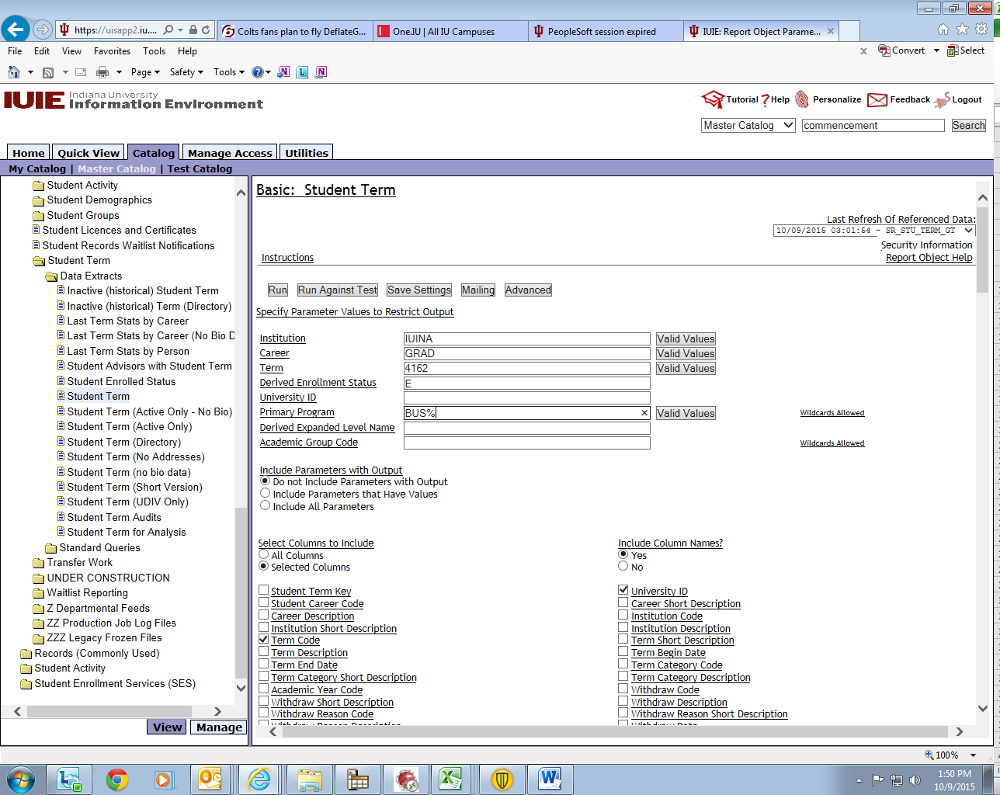
“Derived Enrollment Status” refers to the overall enrollment status of the student. The following is a list of the 6 basic derived enrollment status indicator values and their meanings. For non-IU contract students (ex. SWT or CLN), a Z is appended to the code, e.g. EZ.

Null or blank = There is no enrollment activity for this record. The student is term activated but has not enrolled
X = Deceased
E = The student is enrolled in at least one class that prints on the transcript and is not being audited. If a student is enrolled in an overseas study class with a grade of NY, the derived status on the student term table is set to E, while the derived class enrollment status on the enrollment table is set to T.
A = Enrolled in at least one course, but only as an auditor
W = The student has attempted to register, but is currently only on the course waitlist(s)
D = The student was registered at some point, but subsequently dropped all courses
N = The student is only enrolled in a class that does not print on the transcript, such as a non-graded component class (e.g. a lab section).

Example 2 – Student Term (Term Activated/Enrolled Students Report)
- “Additional Criteria”

You must use the technical names of the fields in order to add additional criteria to a query, but what if you don’t know the technical field name for class number? Click on the words “class number” and you will go to a page that gives you the technical name – copy the technical name by highlighting it and using either Control-C (then Control-V to paste) or the edit/copy and edit/paste commands. Then click on the “back” button at the top left of the browser and paste the technical name in the “Additional Criteria” box. In a box located just below the list of clickable fields, you can re-order the columns if you wish to put them in a more logical order by highlighting the field and using the arrows to move the field up or down.

Example 2 will give you students enrolled in Spring 2016 in the INFO6 program who are coded by the OVMP office (Office of Veterans and Military Personnel) with some type of veterans benefit student group code. Note that you can tell the students have some connection with the OVMP office, but you cannot tell what type of student group they are in – the % sign (wild card) can be replaced with a specific RV code if you are familiar with the coding.

Additional criteria used in Examples 2 and 3 uses data from another table so you must have security to access to both tables. You can check to see if you have access to specific tables by using the “Manage Access” tab, then click on “Users”. In the “Username” field, fill in your user name and click the “Search” button. The middle button is the “View this user’s report object access” – if you click on this button and wait a few seconds, the resulting list will show you the technical names of the tables you may access.

Example 3 – Student Term (Term Activated/Enrolled Students Report)
- “Additional Criteria”

Example 3 produced a list of graduate students in the Kelley School of Business – any students who are in the BUS5 or BUS6 program. By using the combination of Career = GRAD and Program = BUS% you will only get graduate students in the School of Business. However, note that you will not get graduate students who are coded as BUPA5 or BUPA6 – you only get programs beginning with BUS. By using the additional criteria box, this query will eliminate any students who are in-review status for graduation in Spring 2016.

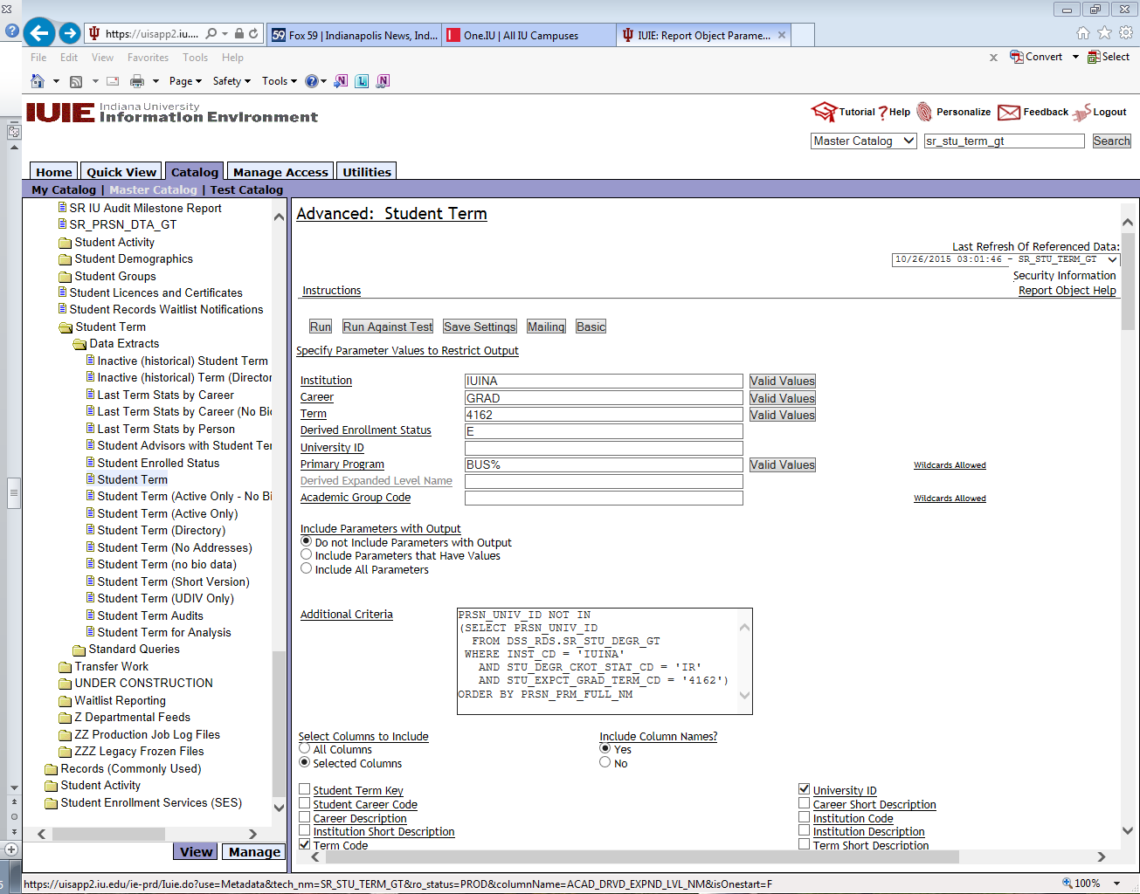

Example 4 – Enrollment by Stack (Student Enrollments) - “Additional Criteria”
This data group contains the course enrollment records for all currently active students. Active students will have their entire history of IU course work posted to this table. Current registration activity as well as graded coursework resides in this table. Students can be enrolled, waitlisted or dropped from a course and will still be listed on this file, although only enrolled courses will have grades. This table includes “active” students (those who have enrolled in at least one course within the last two years)

Path: Master Catalog/Student/Records/Enrollment/Student Enrollments/
Data Extracts/Enrollment by Program Stack
Technical Name: SR_ENRL_BYSTK_GT

This query will produce reports such as class rosters, student enrollments and grade rosters, depending on which fields you select to be returned. Begin with a simple class roster and add
fields such as “official grade” and “FN Grade Indicator” to turn the class roster into a final grade roster at the end of the term.

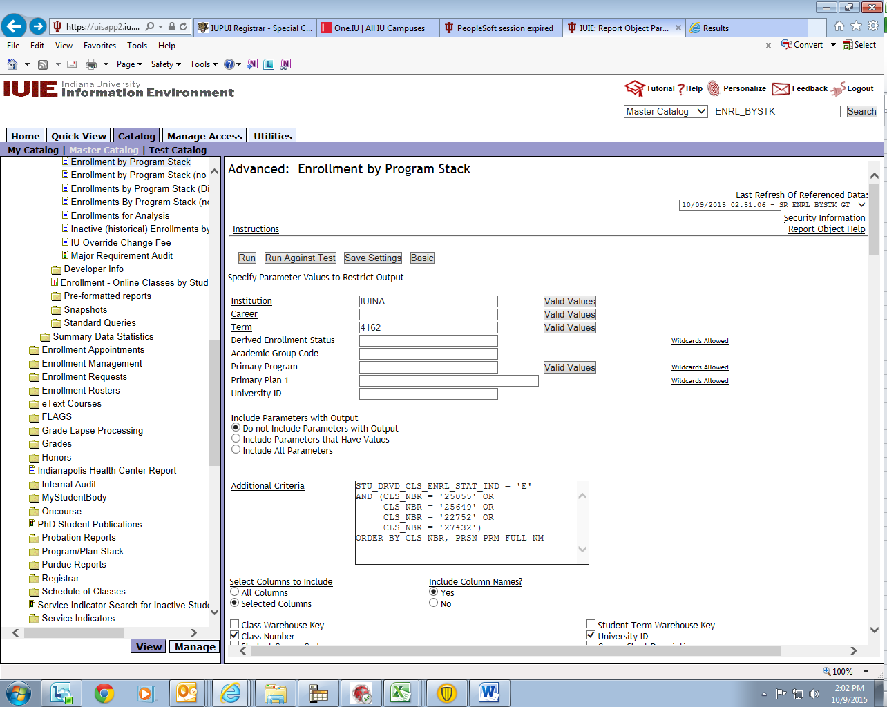

NOTE: The “Derived Class Enrollment Status” (STU_DRVD_CLS_ENRL_STAT_IND), is similar to the “Derived Enrollment Status Indicator”, except that this field indicates the student’s enrollment status in a specific class. This field will appear in each enrollment row, and shows whether the student is enrolled and if the class is a credit class (E or EZ), if the student is auditing the course (A or AZ), on the waitlist for the course (W or WZ), has dropped the course D or DZ), or is enrolled and the class is a non-credit class (N or NZ). Additionally, just like the (term) “Derived Enrollment Status Indicator’, the values indicate whether the student’s program is SWT or CLN – values ending in “Z”.

The allowed values are as follows:

X = Deceased
T = The class prints on the transcript, is not being audited, and is an overseas study class with a grade of NY. This class is counted when determining overall enrollment, but it is not counted when adding the student enrolled units.
E = The class prints on the transcript and is not being audited. This excludes overseas study classes with a grade of NY. Their derived class enrollment status on the enrollment table is set to T.
A = Enrolled only as an auditor in this class.
W = The student has attempted to register, but is currently only on the course waitlist.
D = The student has dropped this class.
N = The class does not print on the transcript, such as a non-graded component class (e.g. a lab section).

Example 5 – Student Degrees

Path: Master Catalog/Student/Records/Degrees/Data Extracts/Student Degrees
Technical Name: SR_STU_DEGR_GT

For students who are in-review for a specific term:

Enter values for:

Institution IUINA
Degree Checkout Status IR
Expected Graduation Term 4162
Use additional criteria to specify the program or the plan.

For students whose degrees are in awarded status for a specific term:

Enter values for:

Institution IUINA
Completion Term 4155
Degree Checkout Status AW

Use additional criteria to specify the program or the plan and the order of output.

This table can be used for any degree checkout status, but the “in review” and “awarded” are the most common. Remember that if the students are “in review”, you must use the “expected graduation term” and if the degrees have been conferred, you use the “completion term” parameter and you may also use the “student degree confer date” for those graduate degrees which can be conferred during any month (for example, the PhD degrees) but have the same degree completion term. This may also be useful with the new possible IU graduation dates for degrees granted in August and December.
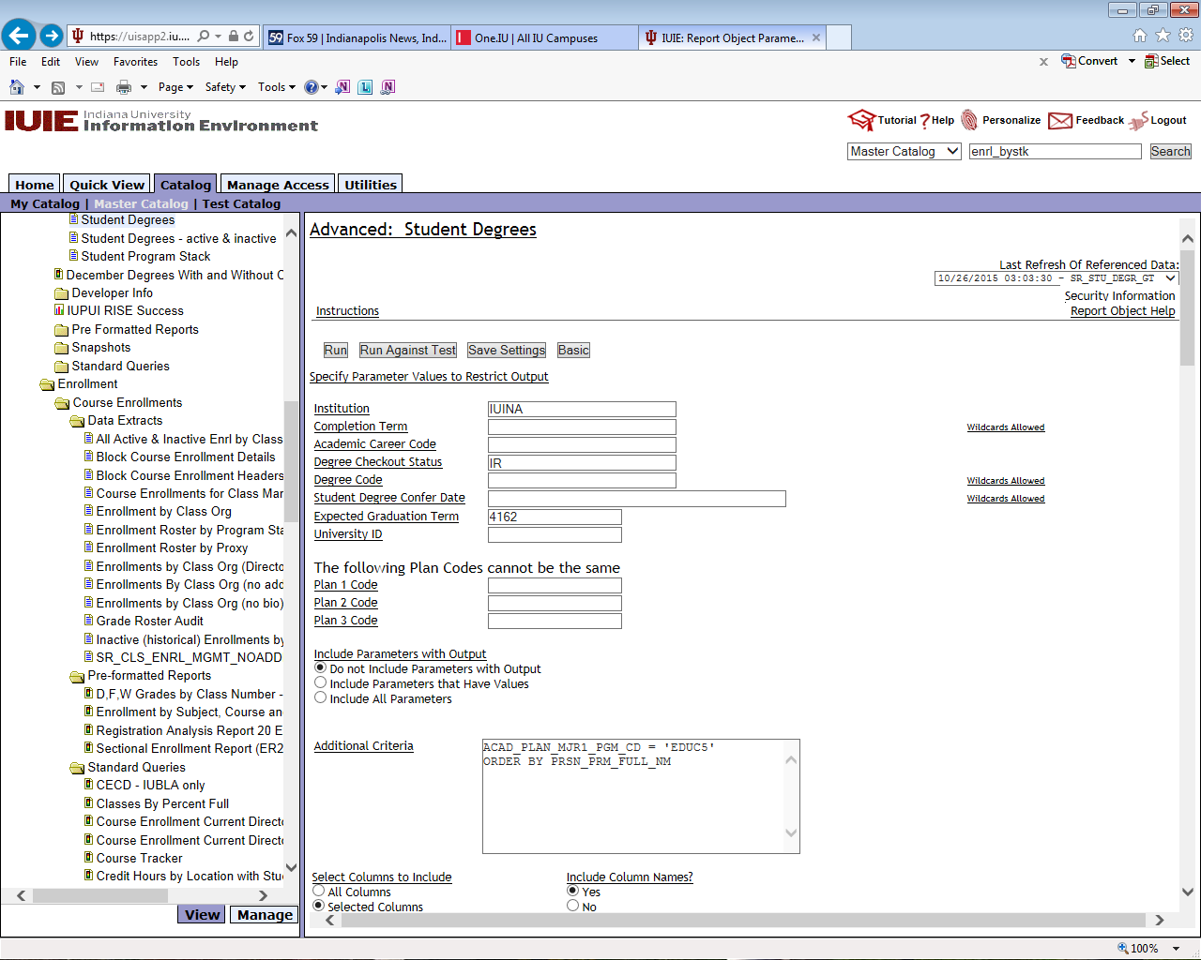

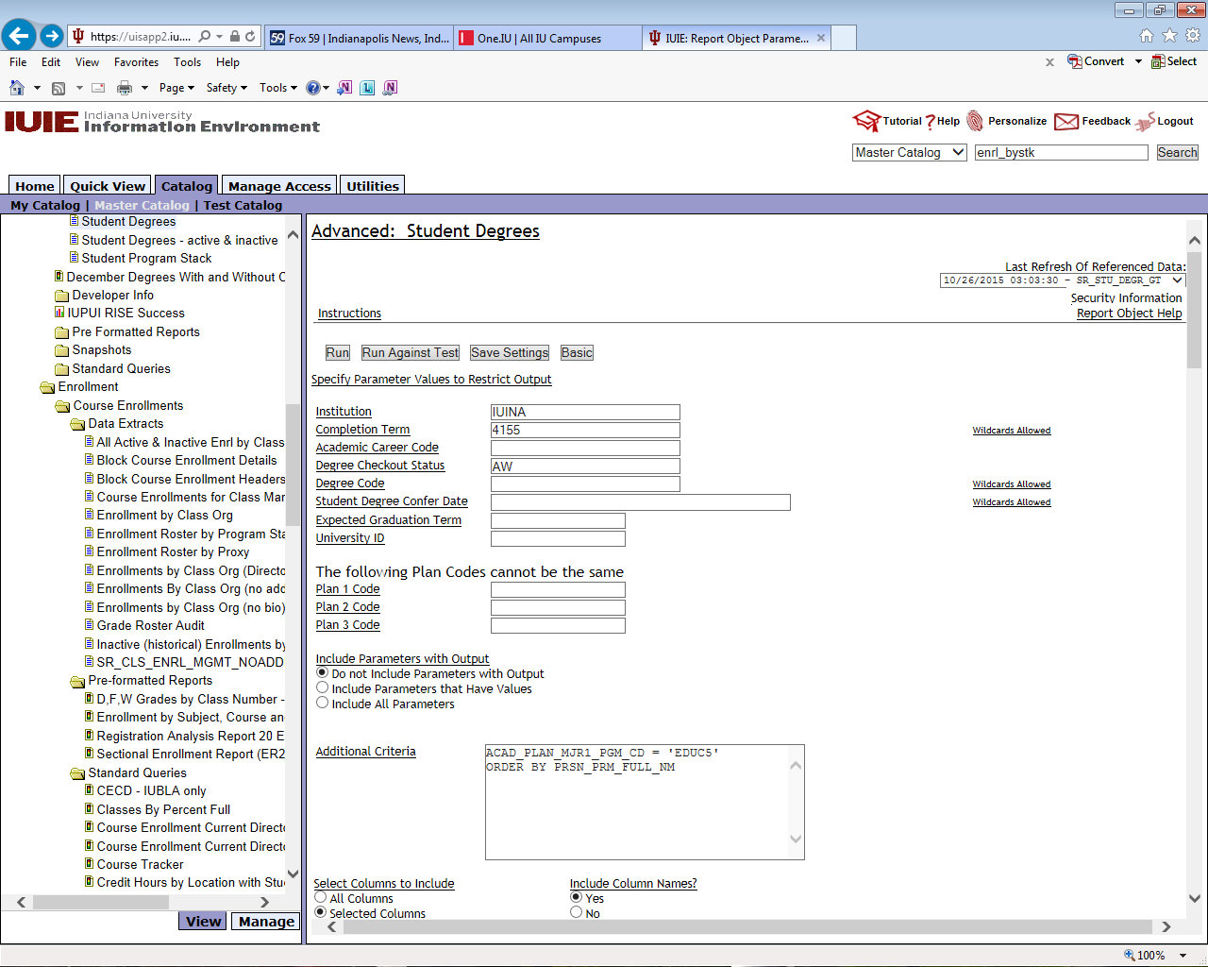
Example 6 – Student Program Stack
Technical Name: SR_STU_PGM_STK_GT

Path: Master Catalog/Student/Records/Program/Plan Stack/Student Program Stack
or Master Catalog/Student/Records/Degrees/Data Extracts/Student Program Stack

The student program stack table provides information on the most recent program stack (rows) for students – it does not include future program stacks. It also is one of the few tables that include information on sub-plans, which many schools now use. This table will also provide information on degrees but will produce one row of output for each plan. (The student degree table lists plans horizontally with one row per student including all of their plans.). For this reason, the table is listed both under the Degrees area and also the Program Stack area. This table is useful for queries where you do not require enrollment information but are just seeking information on program stacks. (Undergraduate schools can use this table to keep track of inter-campus transfers.)

Example 7 - Schedule of Classes Query

Path: Master Catalog/Student/Records/Schedule of Classes/Data Extracts/All Classes, Meetings, Instructors, Associations
Technical Name: SR_CMB_CLS_ASSOC_INSTR_GT
Enter Values for:

Institution IUINA
Term 4162
Subject Dept Code MATH
or
Course Academic Group Code SCI

Remember that before submitting the query, you can click on the “Advanced” button to add SQL statements in the “additional Criteria” box in order to refine your query or re-order columns.

(Note the option to “Return Distinct Rows Only” – by selecting this, your results will only include one row for any selections that include identical data. For example, if you only select class number and course catalog number for a class that has multiple instructors, you would retrieve only one row for that class. If you select class number, course catalog number and instructor name, you would retrieve multiple rows because the addition of the instructor name would make each line different.)

Scroll down to the bottom of the screen and you will see the fields you selected in a box – the IUIE will order the columns in your output in the same order as they are stored in the data warehouse. It is easier to re-arrange your columns in the Advanced area than to wait for the output and re-arrange columns in an Excel file. Highlight the field that is listed last in this box and select “Move Selection Up” to see how the order changes.

SUMMARY

- The best way to learn more about the IUIE is by actually running queries yourself.

- Don’t forget to use the “Search Catalog” option – it will save time.

- Clicking on the name of the report will give you more information about the query or table.

- Clicking on the names of the fields will link you to more information about the data in the fields, including the technical name of the field, possible metadata that explains more about the field, and what other tables contain this field.

- Clicking on the “Valid Values” button will allow you to select only the values you want.

- If you are not sure exactly what data is found in each field, print values for all fields using one of your own students (or yourself) as a “test” and then comparing the output with known values in SIS.

- Use the “Advanced” button (when using data extracts) to add additional criteria. This will allow you to limit your population so you don’t have as much editing when you get output. But everything in the “Additional Criteria” box has to be written in SQL using the technical names of the fields.

- The “no bio” data extracts run more quickly than the other data extracts.

- Limiting the number of records will allow the queries to run faster so you can refine your query before running the entire report, but don’t forget to take the limit off before running your final query.

- Send to completed reports whenever possible. This will allow you to continue working instead of waiting for your query to complete.

- Always save your report objects in My Catalog so you can modify them later. You won’t be happy if you have written a complicated query and then forget to save it!

OR MAYBE NOT….
WHERE DO YOU LOOK?
(…OR LINDA’S FAVORITE TABLES)

BIO-DEMO INFORMATION – SR_STU_TERM_GT – STUDENT TERM
SR_ENRL_BYSTK_GT –
ENROLLMENT BY PROGRAM STACK
SR_LAST_TERM_STAT_BY_PRSN_GT –
LAST TERM STATS BY PERSON
SR_STU_PGM_STK_GT –
STUDENT PROGRAM STACK

REGISTRATIONS (CLASSES) – SR_ENRL_BYSTK_GT –
ENROLLMENT BY PROGRAM STACK
SR_ENRL_BYORG_GT –
ENROLLMENT BY CLASS ORG

STUDENT ENROLLMENT – SR_STU_TERM_GT – STUDENT TERM

PROGRAM STACK - SR_STU_PGM_STK_GT –
STUDENT PROGRAM STACK

SERVICE INDICATORS - SR_SVIND_GT –
SR SERVICE INDICATORS

DEGREE PROCESSING - SR_STU_DEGR_GT – STUDENT DEGREES
SR_STU_PGM_STK_DEGR_GT –
PROGRAM STACK FOR DEGREES

SCHEDULE OF CLASSES - SR_CMB_CLS_ASSOC_INSTR_GT –
ALL CLASSES, MEETINGS, INSTRUCTORS,
ASSOCIATIONS
SR_CMB_CLS_ATTRIB_GT–
ALL CLASSES & ATTRIBUTES

LINDA S. HILL
Technology Support Specialist
Office of the Registrar
LSHILL@IUPUI.EDU
CA 113
274-1509

